A picture is worth of a thousand words.

1. End user goes to Webber site (using https protocol) and tells Webber which “blocked” webpage to visit.
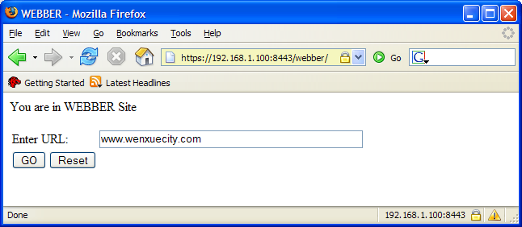

2. “Webber” fetches the web page and securely transfers webpage to end user.
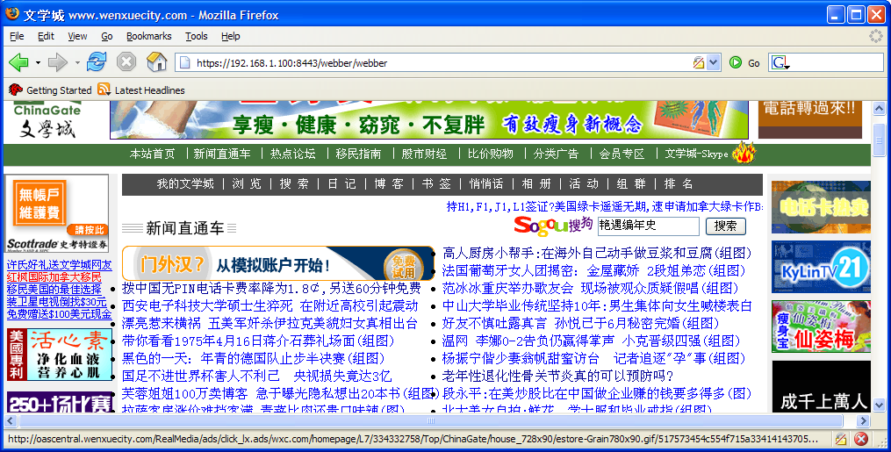

3. Any links in the displayed page will go through Webber.
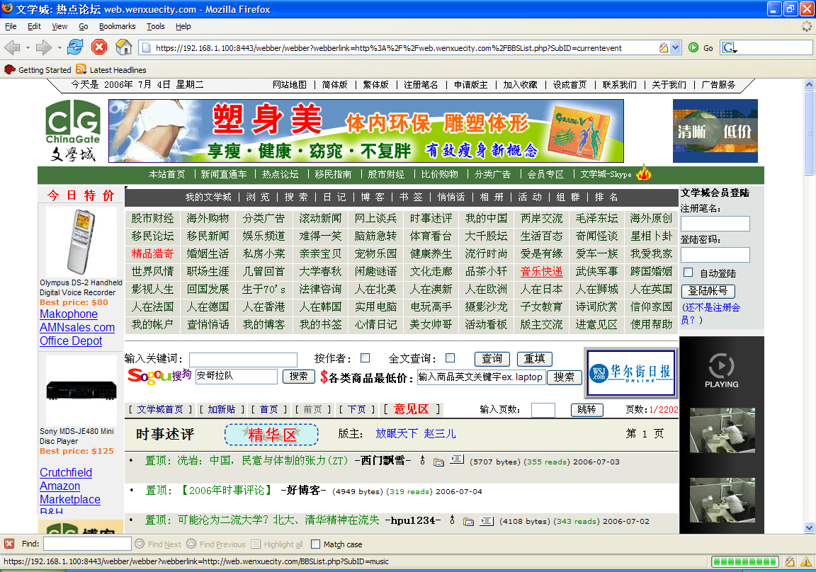

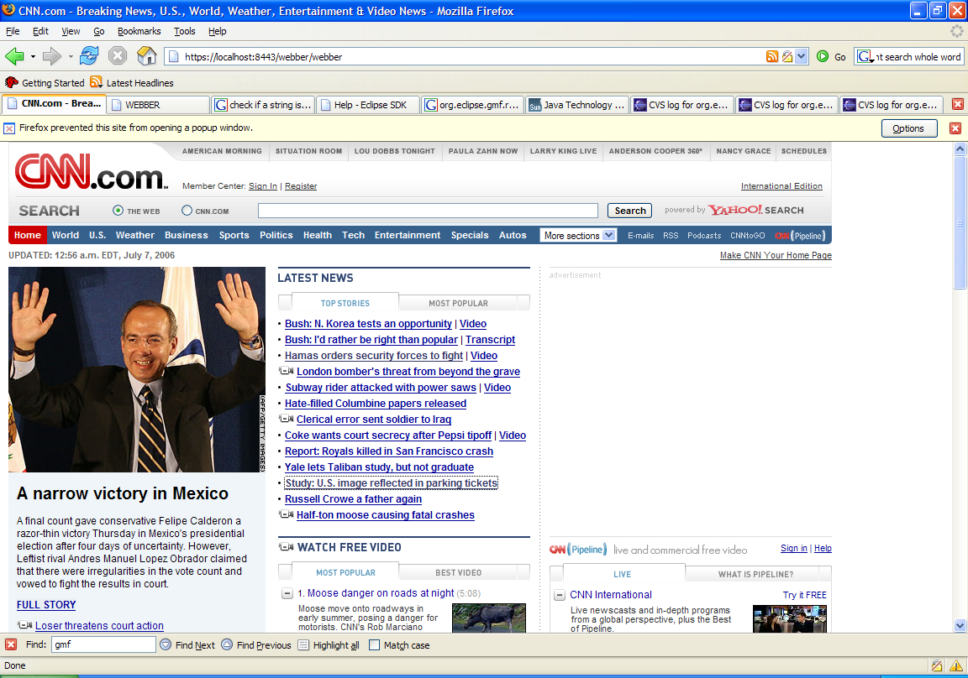

What is Webber?
Webber is a censorship circumvention solution allowing users to access blocked sites in countries where the Internet is censored. Webber turns a regular home computer into a personal, encrypted server capable of retrieving and displaying web pages anywhere.
Who will use Webber?
Webber operates through networks of trust. There are Webber providers, who install and run the server in an uncensored country and Webber users who login and access the server from a country that censors the Internet.
How does Webber work?
Webber acts as a "web proxy" for authenticated users, retrieving requested web pages and displaying them in a user's browser. Webber uses a secure, encrypted connection to receive web requests from the Webber user to the Webber provider who then transports the results back to the Webber user. There is no connection between the Webber user and the requested website, as Webber transparently proxies the request through the Webber provider's computer allowing the Webber user to browse blocked websites seamlessly.
How do users connect to Webber?
Webber users go to their Webber providers' machine using a unique web address. The first page displayed is the user login. The Webber user must login with a valid username and password, given to them by the Webber provider. After authentication, the Webber server displays a toolbar at the top of the page where the Webber user can then enter a website to browse. When using Webber, the Webber user does not have to install any software or change any browser settings.
What do you mean, "the user does not have to install any software"?
After a successful login to the Webber server, the user enters the website address they would like to visit, and Webber takes care of the rest. With a regular Internet browser, the user simply logs in and requests and views the website entered in the Webber toolbar. No software is installed on the end user's machine.
How do users find out about Webber and how is Webber distributed?
Anyone who wants to become a Webber provider and is located in an uncensored country, will be able to download the Webber software from the Webber website. After installation, the Webber provider sends a unique web address to people in need that he or she personally knows and trusts in censored countries.
Even if the Webber website is blocked it does not affect Webber's distribution model. Webber is completely decentralized; each Webber provider is independent of all others. The distribution of access to personal Webber servers is based on social networks. Each Webber provider grows his/her private network based on social relations of trust.

Webber asp.net installation.
“Webber” is an asp.net application. If your machine has Microsoft Internet Information Server (IIS), you can host webber.asp.net. Usually, if you have window 2000 professional or window XP professional, you can have IIS.

- Download webber.net.zipfrom http://www.datawm.com/nastocks/webber.net.zip and unzip the file to a directory, say c:\webber-net.

- Open a window explorer and navigate to c:\webber-net. Right click->Property-> web sharing, make it as a web site of your IIS. (For example you name this asp.net website as “webber”).

3. Follow the following link to set up https connection to webber.
http://www.xenocafe.com/tutorials/self_signed_cert_IIS/self_signed_cert_IIS-art1.php

4.Tell your trusted friends to use Webber. For example, your machine’s public IP is 111.222.333.4444, you tell your friends to go to
https://111.222.333.444: 443/webber.

Bugs in Webber

Webber does not handle script well. For example, you can have Webber to fetch www.google.com page. However, the search function does not work in the “webbered” google page.

Background Information

Webber was developed by J Hu in Hu Enterprise LLC. This software is copy righted. It is free and bears no liability of any kind and in “as it is” status. Please send bug reports, feature requests, criticisms, comments and suggestions to mailto:jhu@datawm.com

Download Webber in http://www.datawm.com/nastocks/webber.net.zip

Webber was technically inspired by “Psiphon” (http://en.wikipedia.org/wiki/Psiphon). However, Mr.Hu was not politically motivated to develop Webber. It is simply a useful tool. Use you conscience.

Webber is free. It only takes good wills to grant access of information to others.

